The basic definition of reasoning by transitivity is easy to neglect. It is remarkable how regularly we use this concept of logic in our everyday life. The classic example a=b, b=c, therefore a=c is quick to say and easy to understand. But as I thought about the subject I realized that this concept is far more prevalent. I thought of various ways that we measure things in our daily lives and it became obvious. Looking at the ruler on my desk I realized that I do not have a tangible idea for what an inch is. But someone else, some trusted authority, does and has marked my ruler accordingly. So as I measure a line on a page all I know for sure is that the line I drew is equal to the distance between 0 and 1 on my ruler. An additional premise is that the distance between 0 and 1 on my ruler defines 1 inch. Therefore, by the power of Reasoning by Transitivity I can declare that the line I drew is one inch long. This means the validity of my declaration is completely related to the accuracy of my ruler’s manufacturer.

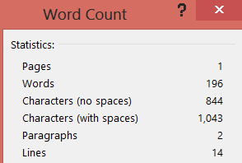

**11/05/2013**